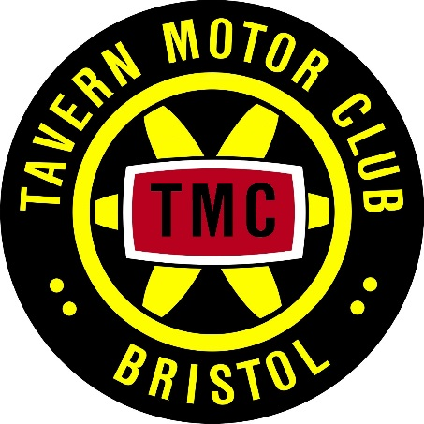
DRIVER
TAVERN MOTOR CLUB
CHEW TOR TOUR REGULARITY 12 CAR
Saturday 21st May 2023
ENTRY FORM

www.tavernmotorclub.co.uk

Name:

Address:

Post code:

Tel No:

Email:

Motor Club:
NAVIGATOR

Name:

Address:

Post code:

Tel No:

Email:

Motor Club:

CAR

Make:

Capacity:

Year:

Model:

Insurance required: Y / N

Reg No:

Insurance is available for all those whose own car insurance does not cover them for this type of event
MONIES

Entry fee £10.00

Insurance (if required) £20.00 Amount enclosed/transferred £

NEXT OF KIN (Name/Address/Tel No)

Driver:

Navigator:

Class (please circle) Expert Novice

Please make cheques payable to ‘Tavern Motor Club Ltd’ or transfer funds to:
Natwest, sort code 52-10-05 account number 01355724 with reference: 12Car-[Driver’s last name]

Email this form to Daniel.Stone@inspirolearning.co.uk or post to:
Daniel Stone, 5 Wellington Drive, Bristol, BS9 4SR
‘I declare that I have been given the opportunity to read the General Regulations of Motorsport UK and, if any, the Supplementary Regulations for this event and agree to be bound by them. I declare that I am physically and mentally fit to take part in the event and I am competent to do so. I acknowledge that I understand the nature and type of the competition and the potential risk inherent with motor sport and agree to accept that risk.

‘I understand that motorsport can be dangerous and accidents causing death, injury, disability and property damage can and do happen. I understand that these risks may give rise to my suffering personal injury or other loss and I acknowledge and accept these risks. In consideration of the acceptance of this entry I agree that neither any one of or any combination of Motorsport UK and its associated clubs, the organisers, the track owners or other occupiers, the promoters and their respective officers, servants, representatives and agents (the “Parties”) shall have any liability for loss or damage which may be sustained or incurred by me as a result of participation in the Event including but not limited to damage to property, economic loss, consequential loss or financial loss howsoever caused. Nothing in this clause is intended to or shall be deemed to exclude or limit liability for death or personal injury. To the fullest extent permitted by law I agree to indemnify and hold harmless each of the Parties in respect of any loss or damage whatsoever and howsoever arising from my participation in this event.

'I declare that to the best of my belief the driver(s) possess(es) the standard of competence necessary for an event of the type to which this entry relates and that the vehicle entered is suitable and roadworthy for the event having regard to the course and the speeds which will be reached'.

‘I have read and fully understood the regulations for Control of Drugs and Alcohol as contained in the Competitors’ and Officials’ Yearbook Regulations H39, D35.1, G15.1.4 and have also fully familiarised myself with the information on the web sites referred to (www.motorsportuk.org, www.ukad.org.uk and www.wada-ama.org) in particular the UK Anti Doping Rules which have been adopted by Motorsport UK. Further, if I am counter-signing as the Parent or Guardian of a minor then in addition to the deemed consent to the testing of that minor UK Anti-Doping Rule 5.7.2) I hereby confirm that I give such consent for the minor concerned to be so tested.’

‘I hereby agree to abide by the Motorsport UK Safeguarding Policy and Guidelines and the National Sporting Code of
Conduct.’

Drivers signature:
Date:

State your age if you are under 18

Navigators signature:
Date:

State your age if you are under 18

I am the Parent or Guardian of the driver / navigator and ‘I understand that I shall have the right to be present during any procedure being carried out under the Supplementary Regulations issued for this event and the General Regulations of Motorsport UK.’ As the Parent/Guardian ‘I confirm that I have acquainted myself and the minor with Motorsport UK General Regulations, agree to pay any appropriate charges and fees pursuant to those Regulations (to
include any appendices thereto) and hereby agree to be bound by those Regulations and submit myself without reserve to the consequences resulting from those Regulations (and any subsequent alteration thereof). Further, I agree to pay as liquidated damages any fines imposed upon me up to the maxima set out in Part 3, Appendix 1.’

(Where the Parent is not present there must be a Guardian who must produce a written and signed authorisation from the Parent/Guardian to act as their representative).
I declare that I am the Parent / Guardian of the Entrant / Driver / Navigator

Signature:
Date:
Tel No:

Address:

Data Protection Act / General Data Protection Regulation: The information declared on this entry form will be held on computer for membership administration and Tavern Motor Club event or championship purposes only. This includes emailing you about Club events and newsletters. If you do not wish your personal data to be used in this manner please tick the box.
[ ]

